Task on vpc-2
- Create one VPC, with 1 public subnet and 1 private subnet.
First we Create one vpc

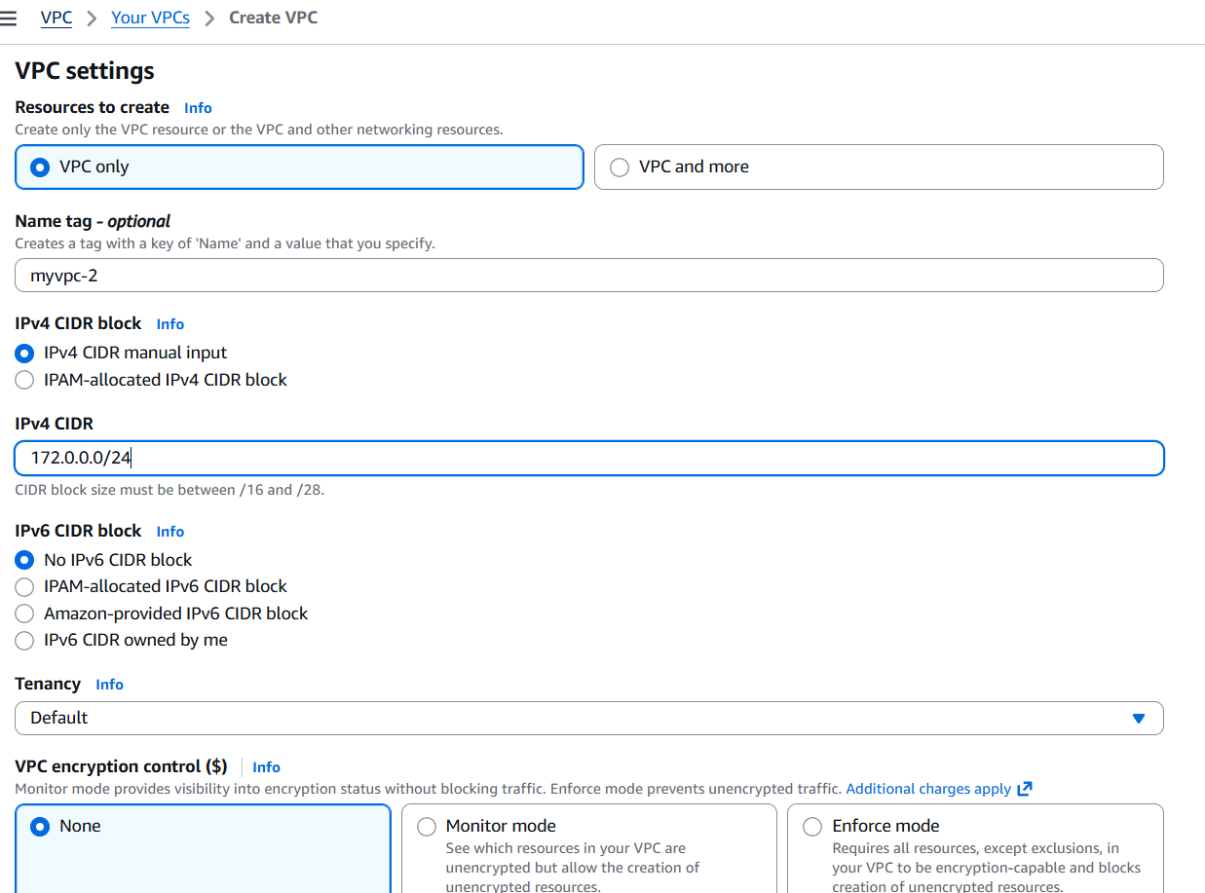
After go to subnets create public and private subnets

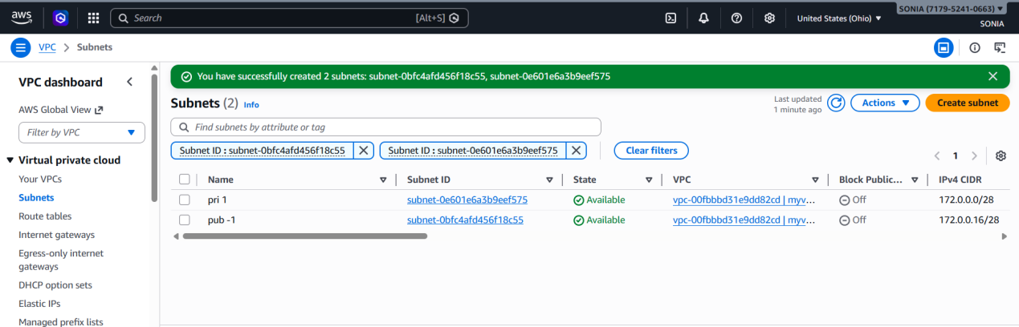
- Enable VPC peering for cross-region.
First we create n.virginia vpc
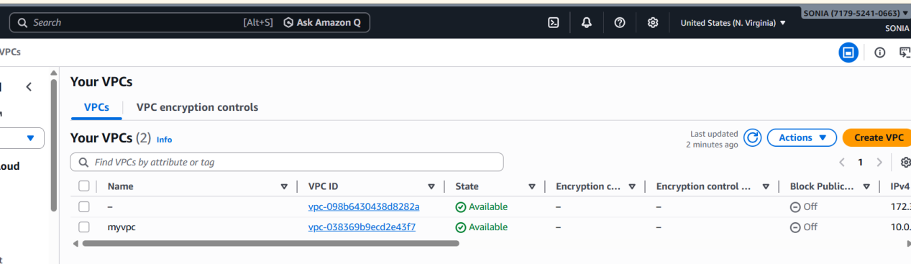
Then we well go to subnet --> create private and public subnets
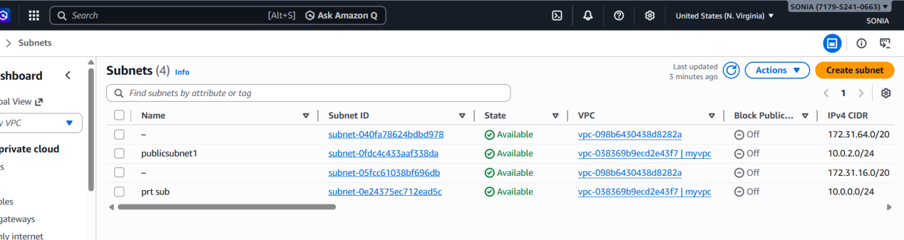

open route tables and create route tables for private and public keys separate
then go to internet gateway create IGW for public keys go to route tables -->open subnet assosiactions save edit routes select enter integrate way was entered successfully

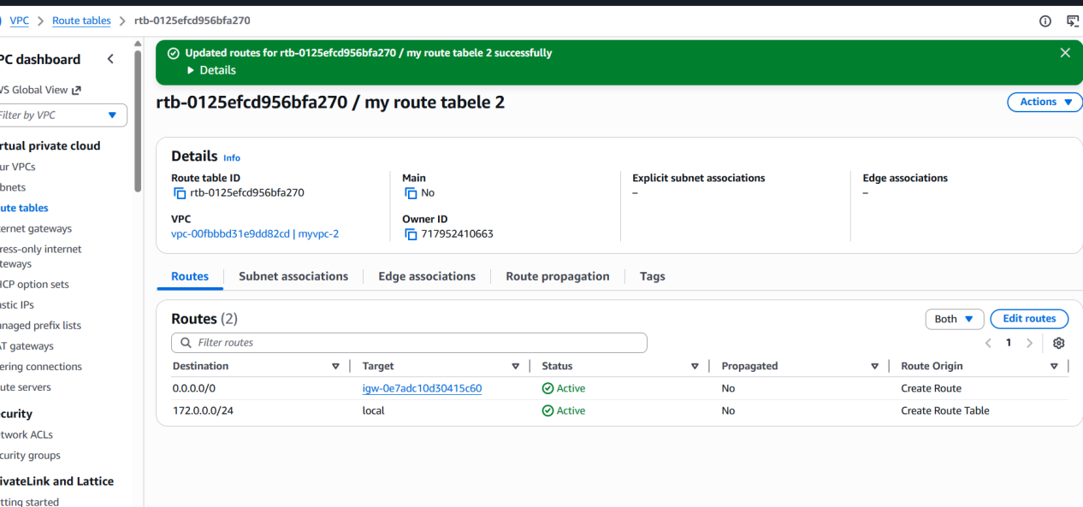

peering connectionFrom ohio to N.virgina give that regionconnect the ohio pem to git bash
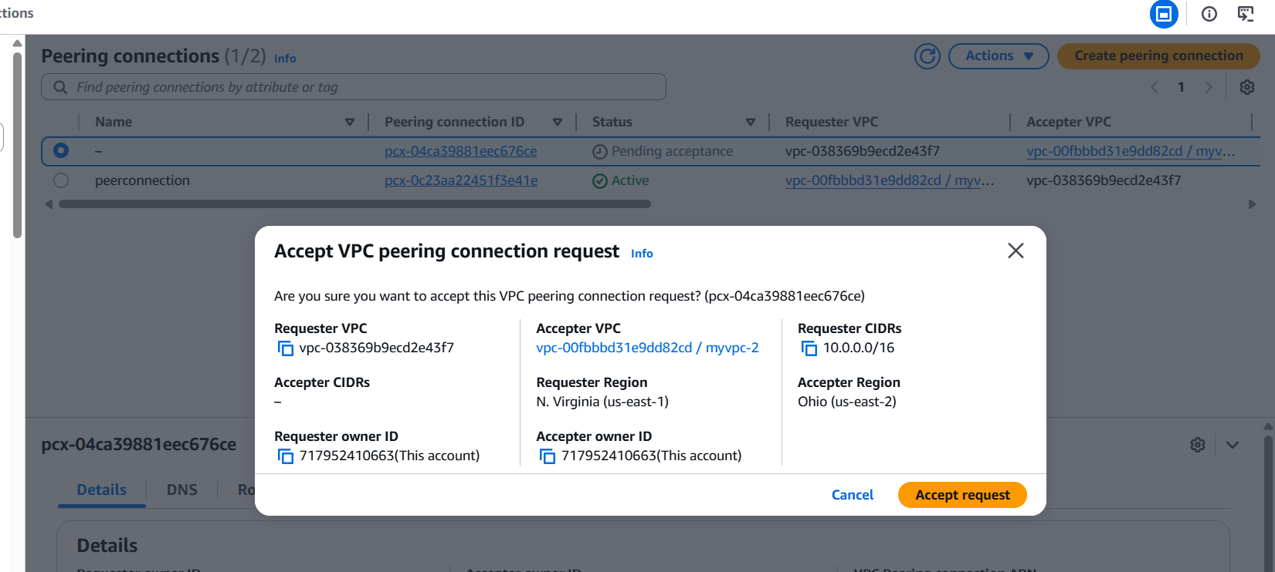

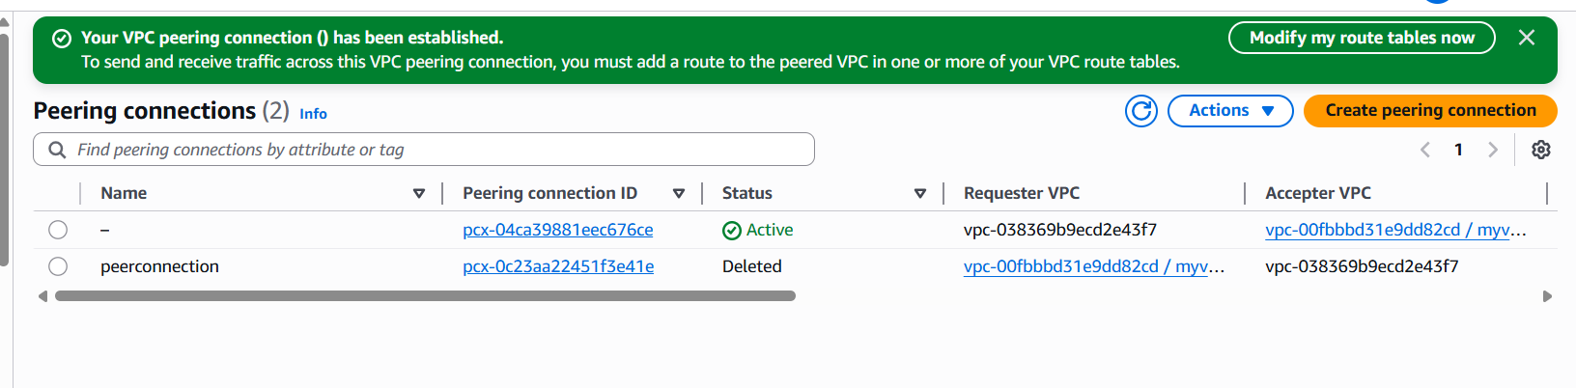
ping ip address of n.virgina we have connection of peering successfully.

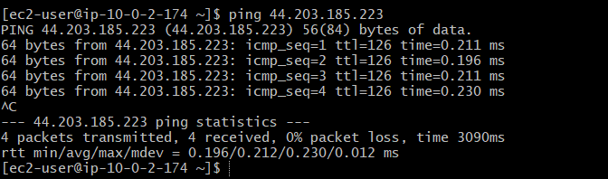
- Enable VPC peering for cross-account (you can collaborate with your friend to do this task)

In this I have to open the vpc peering connectionsselect myvpcanother accountanother region here I can give my fri account id and vpcidconnection of peering successfullymy fri go to their route table and add my cidr number in their vpcand now connect my public instance to git bashping friend pub ip addresssuccesfully running.
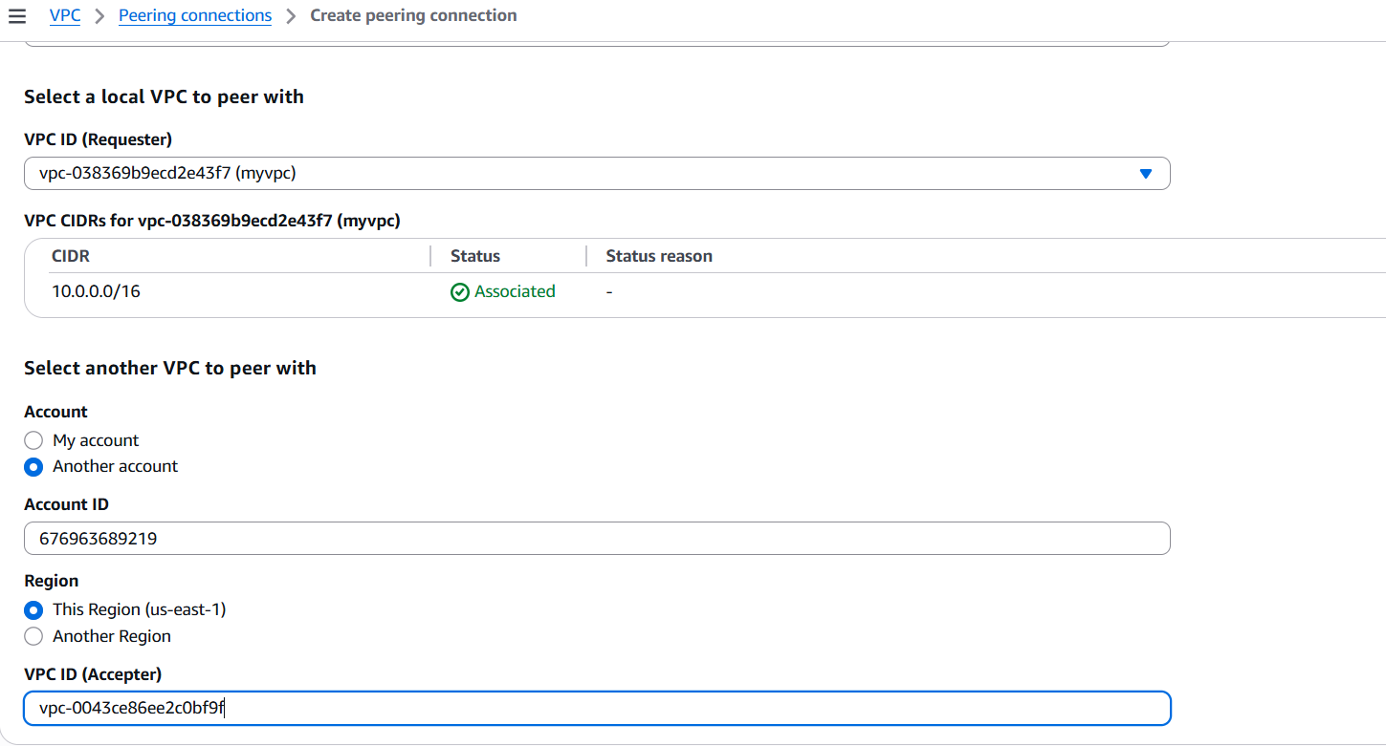
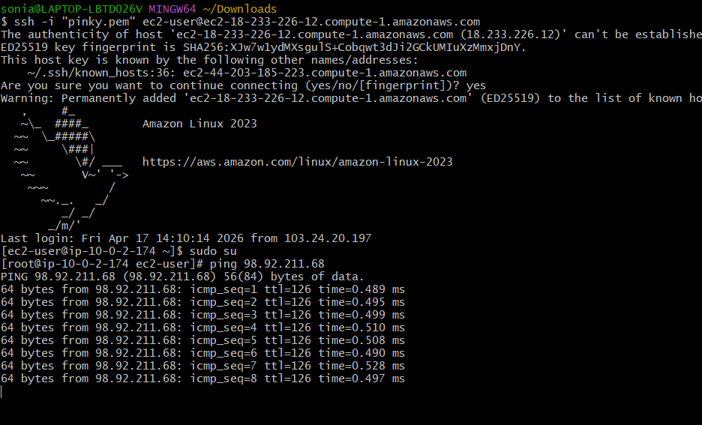

- Set up a VPC Transit Gateway.
First we go to vpc and create 4 vpc in the region

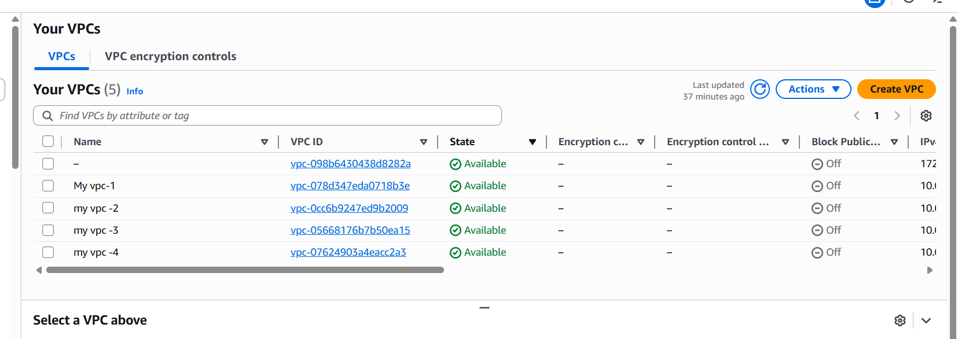
Then we well go to subnet create every vpc private and public sunbnets
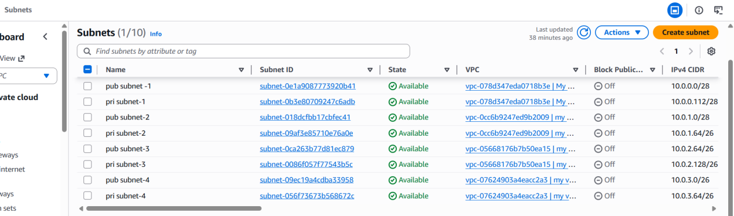

Next we create route tables for every vpc
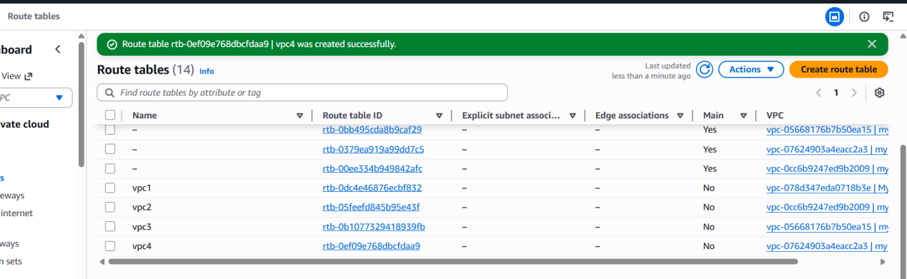
After completing route tables creatinginternet gateway was created for every vpcthat vpc has attached or detached see once go to subnet associations created successfullyafter created then we want to give routes connection to route tables in with igw

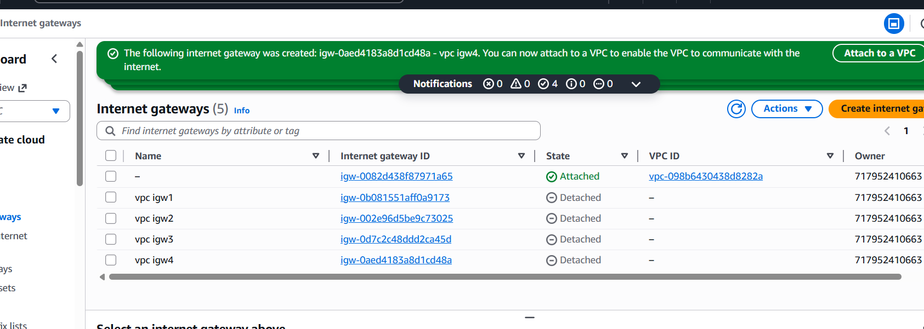
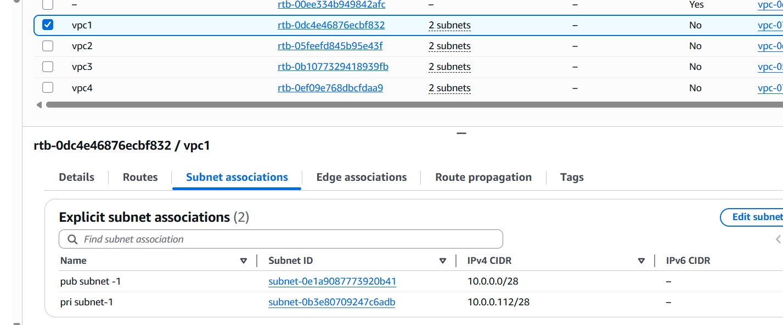
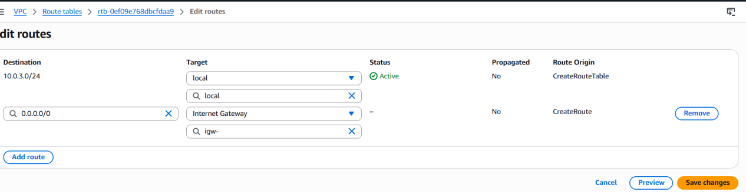

Create transit gatewyas
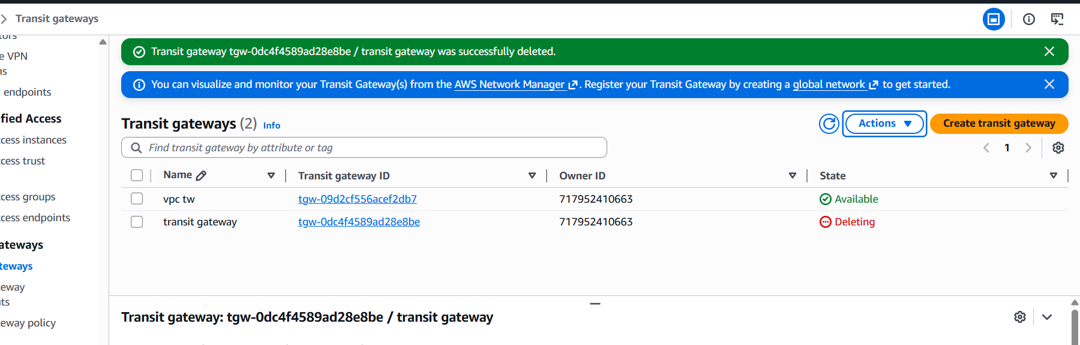
Now I created every transit gateway attachements different different vpcs with different transit attachements after completed attachements I want to check the connections are associated or not.
check below transit gateway route tables

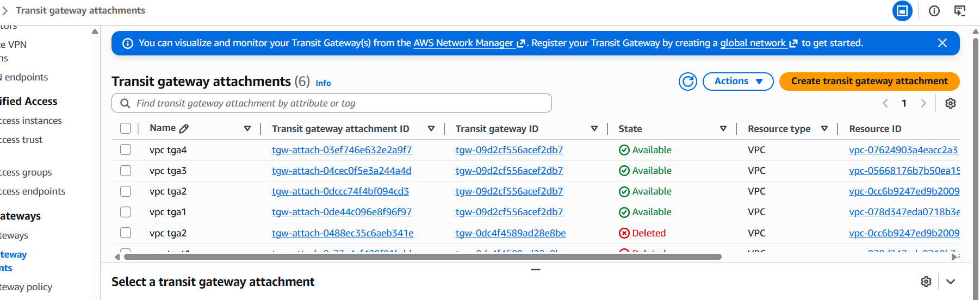
Go to route tables and add any vpc have to connect all extra three cidr numbers with transit gateway id shown in below

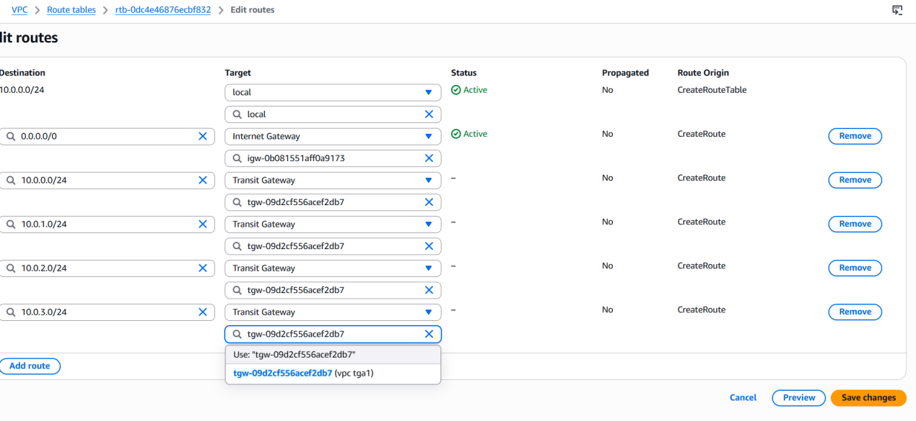
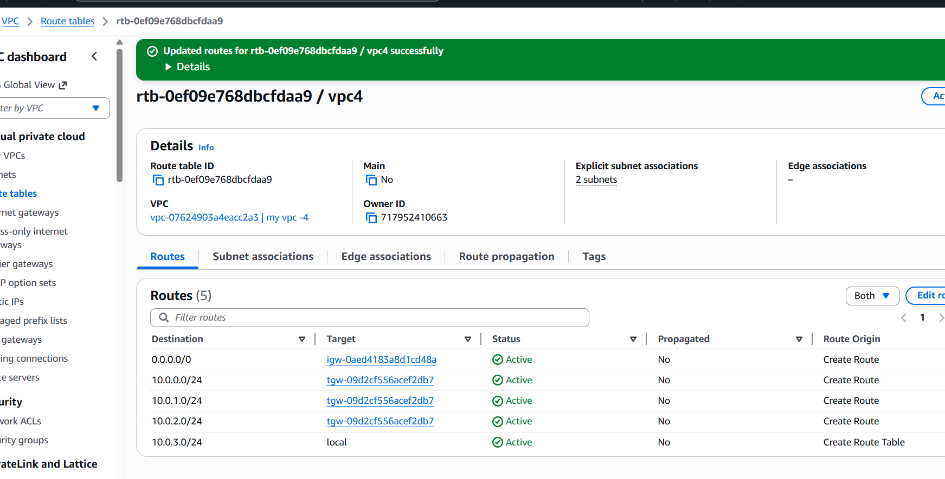
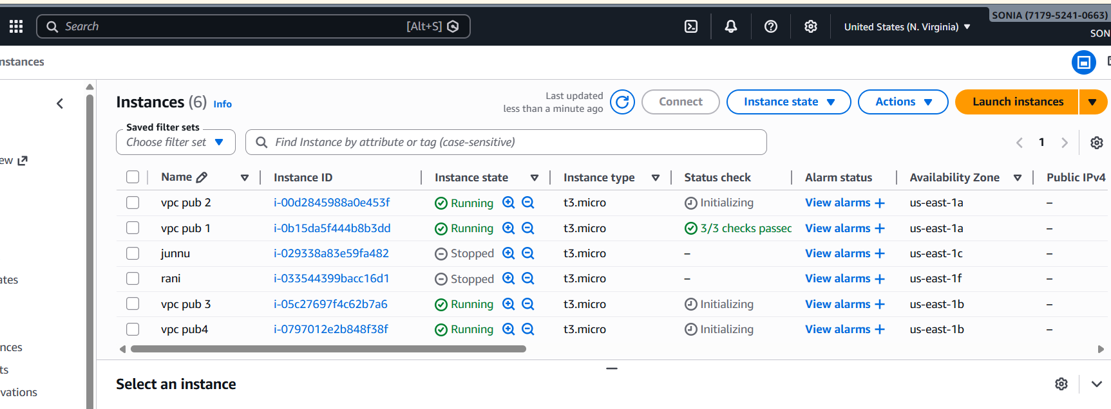
Now go to git bashconnect instance ping ip address of public address of another vpc

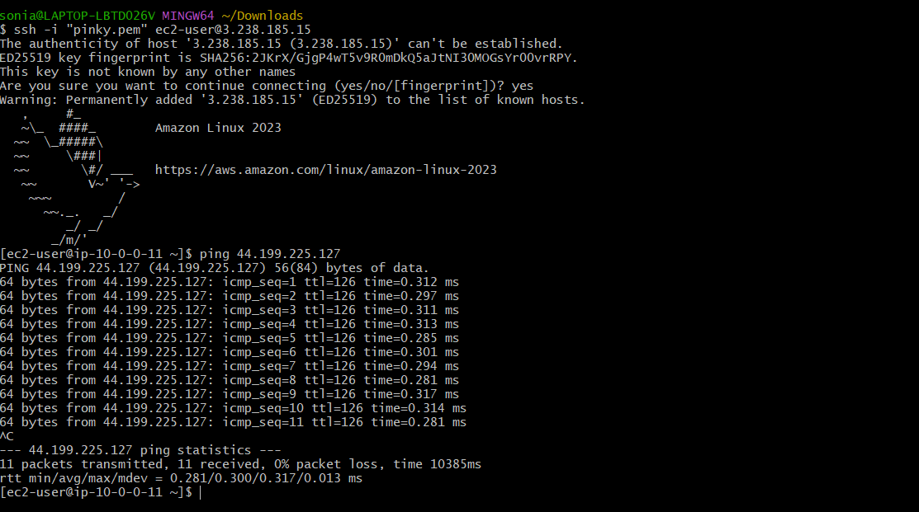

5)Set up a VPC Endpoint.
Create endpoint collecte s3 servies and servies name us-esat-1.s3 gateway

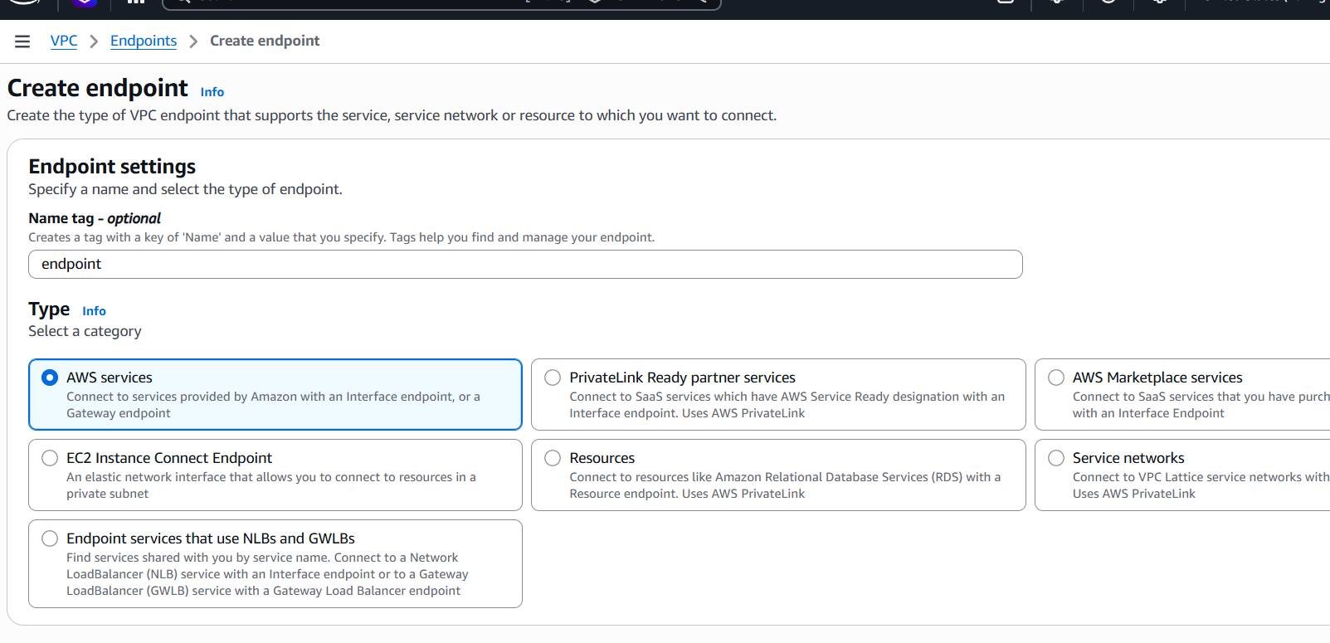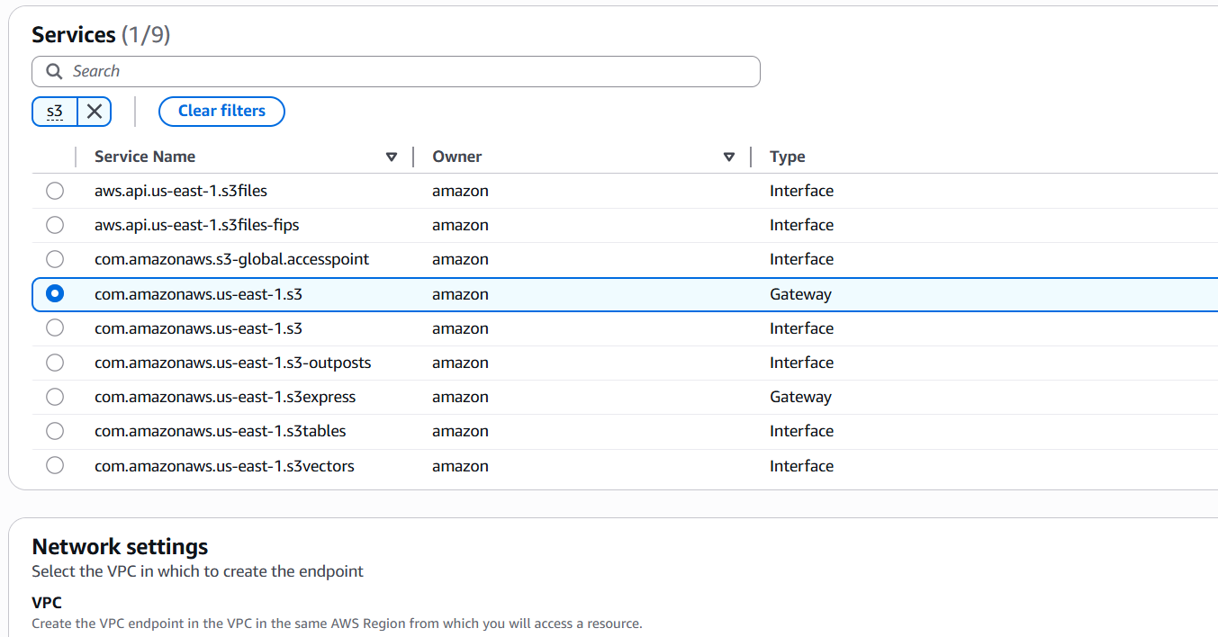

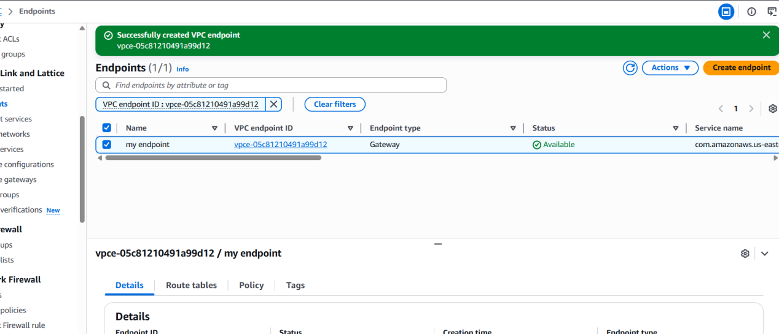

We have to see here destination pi adress

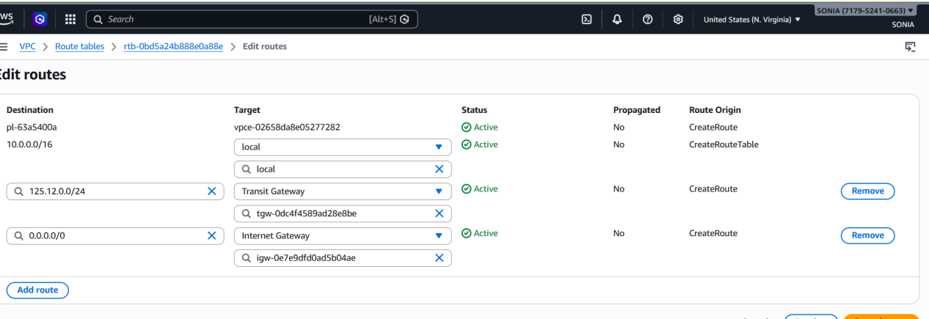
Then go to our account id and select credentialsselect access key pairdownload.csv filego to git bash and connect with the any instance
aws configureaccess key id shown in below.

